**Wake Technical Community College**

**CSC120 Computing Fundamentals I – Spring 2022**

**Instructor: Curtis Knowles**

**LAB 4 – Lessons 4 and 5: Python Programming, Parts 1 and 2**

**DUE DATE:**

This lab is due by Sunday 2/13 (11:59pm ET). Wake Tech does **NOT** allow any late submissions for this assignment.

**OBJECTIVES:**

In this lab assignment, students will review the following concepts in Python:

* Coding Basics of Variables, Data Types, and Assignments
* Input, Processing, Output
* Conditional Structures – the if statement
* Looping Structures – the while and for loops
* Using Lists

**GRADING:**

This lab is worth 100 points. Submit all required files as attached files to the Lab 4 submission in Blackboard in a Word document named **Lab4_<Last>_<First>.docx.**

For this lab, you will copy/paste the code you write in PyCharm into the Word document and submit it that way for grading. **DO NOT** copy/paste screenshots of your code into the Word document (points will be deducted if you do this). Instead, copy/paste the actual code text into the Word document. I must be able to copy/paste the code from Word back into PyCharm to make sure it runs without error in PyCharm.

#### Reference code

Below is reference code you can use and modify to answer the questions in the lab.

**# reference code #1 - for loop examples**

for i in range (99):

print (i)

**# reference code #2 if condition example**

a = int (input ("enter the first number"))

b = int (input ("enter the second number"))

if a == b:

print ("numbers are equal")

else:

print ("numbers are not equal")

**# reference code #3 for creating a an empty list**

my_list = []

**# reference code #4 for traversing through items in a list**

my_list = [1, 3, 5, 7, 9]

for i in my_list:

print(i)

**# reference code #5 for adding elements to a list**

my_list = []

for i in range (11):

my_list.append(i)

print (my_list)

**# reference code #6 for printing string length**

name = "Waketech"

print (len(name))

##### Question 1 (10 points)

### Write a for loop that prints all numbers from 10 to 99. (Hint: modify the above reference code #1 suitably.)

##### Question 2 (10 points)

##### Write a program to input a number from the user. Determine if the number is single digit or double digit. For example, your program should produce the following output. Use if .. else. You can assume the only numbers the user will enter are between 0 and 99.

##### (Hints: modify the above reference code #2 suitably. The if condition in this case would be a Boolean expression that is true for any double-digit number between 0 and 99, but false for any single-digit number in that same number range.)

**Expected Output:**

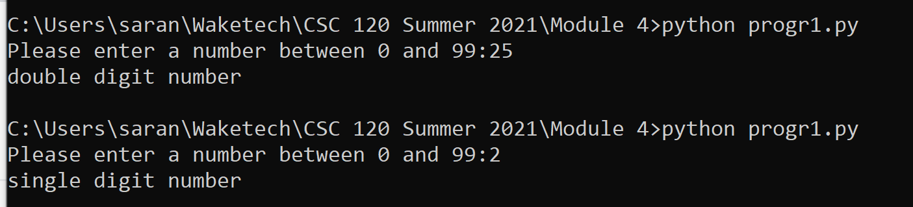

##### Question 3 (10 points)

Write a for loop that prints all even numbers from 10 to 99. (Hints: modify the above **reference code #1** suitably. The calculation to determine an even number is if the number % 2 has a remainder of 0.)

##### Question 4 (10 points)

### Write a for loop that prints the table of 5 as follows. (Hint – modify the above reference code #1 suitably. What would the “step” argument of the range function need to be in this case?)

**Output:**

5

10

15

20

25

30

35

40

45

50

##### Question 5 (10 points)

Write a for loop that prints all numbers in the table of 5 that are divisible by 3. For example your loop should print the following. (Hints: modify the code you wrote for Question 4 to add the new requirement. You will need an if condition inside of the for loop for the new requirement.)

**Output:**

5

10

15 is divisible by 3

20

25

30 is divisible by 3

35

40

45 is divisible by 3

50

##### Question 6A (5 points)

How would you fix the following error?

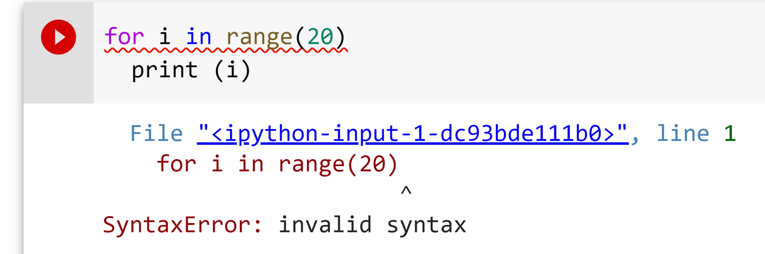

**Question 6B (5 points)**

How would you fix the following error?

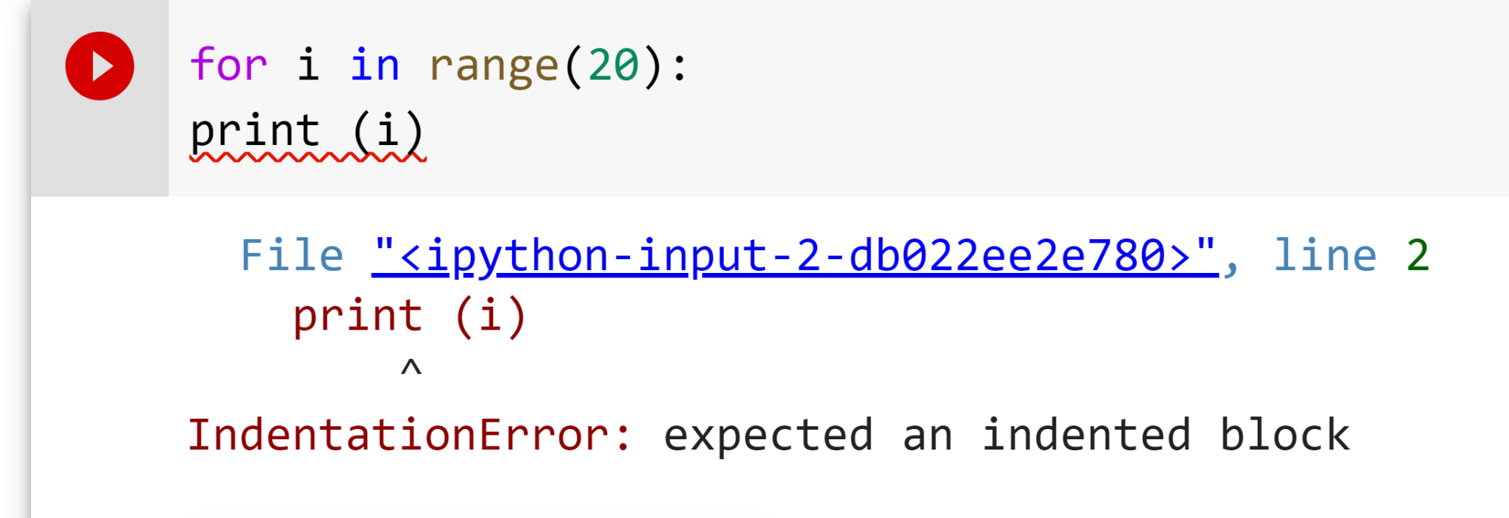

**Question 7 (10 points)**

You have the below list. Print all the elements from this list. (Hint: you do not need a loop to do this. You can use a single Python command.)

# Python code

prices = [10, 130, 25, 64, 91, 66, 42, 18, 141, 64]

**Question 8 (10 points)**

You have the below list. Filter all elements from this list that are greater than 20 and less than 80. Add them to a new list. The name of the list with filtered elements should be **filtered_list.**(Hints: use **reference codes #3, #4, and #5** to build your coding solution. Build a step-by-step algorithm – 1. initialize filtered_list, 2. traverse through the prices list, 3. for each item in prices list, see if it should be added to filtered_list, 4. if so, add it to filtered_list, 5. go to next item in prices list and repeat.)

# Python code

prices = [10,130, 25, 64, 91, 66, 42, 18, 141, 64]

**Question 9 (10 points)**

Write a program that accepts a username and a password from the user. If the username entered is “student007” and password entered is “new_password”, your program should print a message **“Login successful”.** Otherwise, it should print a message **“Try again. Login failure”.**

**Note:** Use the **logical AND** in your if condition for full credit. Your solution will also require an if .. else.

**Expected Output**

**Case 1**

Please enter username: student007

Please enter the password: new_password

Login successful!

**Case 2**

Please enter username: student007

Please enter the password: new111

“Try again. Login failure”.

**Case 3**

Please enter username: student008

Please enter the password: new111

“Try again. Login failure”.

**Case 4**

Please enter username: abcde

Please enter the password: xyzw

“Try again. Login failure”.

**Question 10 (10 points)**

Write a program to accept a username from the user. If the length of the username is less than 5 or if the length of the username is greater than 16, your program should print “Invalid username”. Otherwise your program should print the message “valid username”.

Use **logical OR operator in your if condition** for full credit. Your solution will also require an if .. else.

(Hint: Use the len () function example in **reference code #6** to find the length of the username which you provide as input to your program.)

**Expected Output**

**Case 1**

Please enter username: student1

Valid username

**Case 2**

Please enter username: stud

Inalid username

**Case 3**

Please enter username: student12233

Invalid username

**(20 points) Challenge Question 1 (Extra Credit)**

# Python code

item_prices = [10, 40, 1, 16, 25, 34, 49, 40]

You have a list of prices of items in a store. Write a program that prints all pairs of items that add up to 50. Your program should print the output as follows

**Output**

10 , 40

10, 40

1, 49

16, 34

**(10 points) Challenge Question 2 (Extra Credit)**

#Python code

names = ["sarang","john","lily","jasmine","mara","dave","chester"]

Write a program to search a name in a list of names. If the name is found, print “name found: <name>”. Otherwise print “name not found”. Use the above names list in your code.